9.86: The gravitational potential energy which has become kinetic energy is
In terms of the common speed v of
the blocks, the kinetic energy of the system is
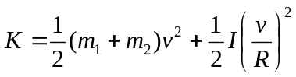
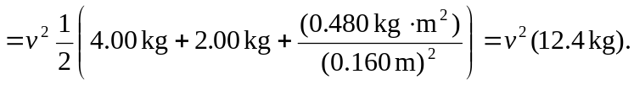
Solving for 